In -Class Practice

### Practice

As you work through this section, be sure that you really understand each of the programs, and call for help if you don't!

1. In a new browser tab, visit [the online Python 3 tutor](http://www.pythontutor.com/visualize.html#code=%0A&mode=undefined&cumulative=false&py=3) and enter the following Python code:

Practice

As you work through this section, be sure that you really understand each of the programs, and call for help if you don't!

In a new browser tab, visit the online Python 3 tutor and enter the following Python code:

def main():

x = 7

if x < 0:

print('negative')

else:

if x == 0:

print('zero')

if x > 0:

print('positive')

main()

1. Then click "Visualize execution."
2. Using the visualizer to help you if necessary, answer Questions 1 and 2 in your writeup. Try to answer the question without using the visualizer at first, and then use it if you get stuck.  
     
   Syntax Error – We get this error because of multiple indentation errors after the ‘else’ statement. To fix it, I correctly indented the code below the ‘else’ statement.   
     
   After the fix, the program outputs the result as ‘positive’.

Fixed Code:  
 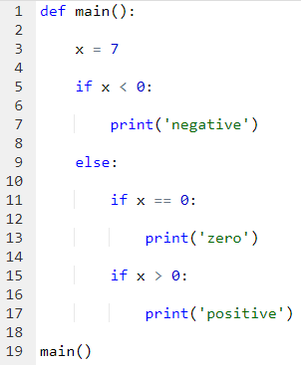

1. Modify the if-statements as follows (changes are **bold and highlighted**):

print('negative')

if x < 0:

print('negative')

**else:**

**print('non-negative')**

Then click "Visualize execution."

1. Using the visualizer to help you if necessary, answer Questions 3 and 4 in your writeup. Try to answer the question without using the visualizer at first, and then use it if you get stuck.  
     
   In this version of the code, once ‘x < 0’ fails, i.e if the number is a non-negative, it will automatically print out ‘non-negative’ even before checking to see if the number is a positive number or a zero. After printing that, it will check if it is a positive number or a zero and print accordingly (again).

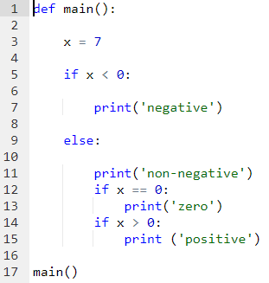   
   
 

1. Next, try the following code

def main():

num = 55 # TODO: change this value

if num == 0:

num += 2

print('Your value is now ', num, '.', sep="")

else:

num += 4

print('Your value is now ', num, '.', sep="")

if num > 0:

num -= 4

print('Your value is now ', num, '.', sep="")

main()

1. Answer Question 5 in your writeup without running the program. Then run the program to check your answers.  
     
   In this code, first the program checks if the number is a ‘0’ or not. If the number happens to be a ‘0’, the program will add ‘2’ to the number and print the output(2) along with the prompt specified and if it doesn’t happen to be ‘0’, the program will add ‘4’ to the number and print the output along with the prompt specified.  
   Then, it will again check if the current number (after the calculation/if statement above), is greater than zero. If it is, the program will subtract 4 from the number and print the output along with the prompt specified. If it is not, the program will end without printing anything from this section of the code.  
     
     
   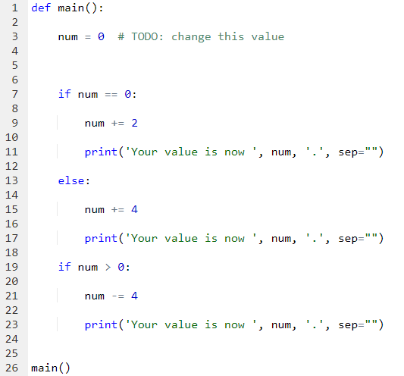  
     
   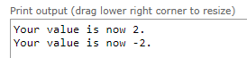
2. Next, try the following revisions (changes are **bold and highlighted**):

if num == 0:

num += 2

print('Your value is now ', num, '.', sep="")

**if num < 0:**

num += 4

print('Your value is now ', num, '.', sep="")

**else:**

num -= 4

print('Your value is now ', num, '.', sep="")

1. Answer Question 6 in your writeup.  
     
   In this version of the code, the first if statement does the same task. It checks if the number is a zero and if it is, adds ‘2’ to the number and prints out the number (which will be 2) along with the prompt specified.   
     
   Then the program goes through another if statement checking if the number is smaller than ‘0’ or not. If it is, the program adds ‘4' to the number and prints out the output along with the prompt specified. If not, the program will subtract 4 from the number and print it out along with the prompt specified.

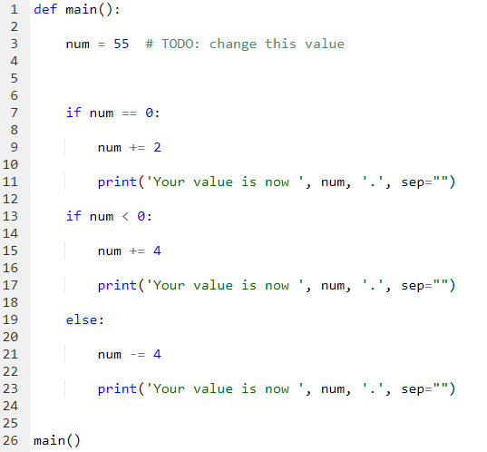  
  
 

1. Next, try the following revision (changes are **bold and highlighted**):

if num == 0:

num += 2

print('Your value is now ', num, '.', sep="")

**elif num < 0:**

num += 4

print('Your value is now ', num, '.', sep="")

**if num > 0:**

num -= 4

print('Your value is now ', num, '.', sep="")

1. Answer Question 7 in your writeup.  
     
   In this version of the code, the first if statement checks if the number is a zero and if it is, adds ‘2’ to the number and prints out the number (which will be 2) along with the prompt specified. But If it is not a ‘0’, the program runs the ‘elif’ statement which checks if the number is less than 0. If It is, the program adds 4 to the number and prints it out along with the prompt specified.  
   After that, the program checks if the number is greater than ‘0’. If it is, it subtracts ‘4’ from it and prints the output along with the prompt specified.
2. Finally, link together your if-statements as follows (changes are **bold and highlighted**):

if num == 0:

num += 2

print('Your value is now ', num, '.', sep="")

elif num < 0:

num += 4

print('Your value is now ', num, '.', sep="")

**else:**

num -= 4

print('Your value is now ', num, '.', sep="")

1. Answer Question 8 in your writeup.  
     
   In this version the program checks if the number specified is equal to ’0’, smaller than ‘0’. or greater than ‘0’. If the program is equal to ‘0’, it adds ‘2’ to the number; if the number is less than ‘0’, it adds ‘4’ to the number; and if it is greater than ‘0’, it subtracts ‘4’ from the number.  
   After doing the calculation, it prints out the number along with the prompt specified.   
     
     
   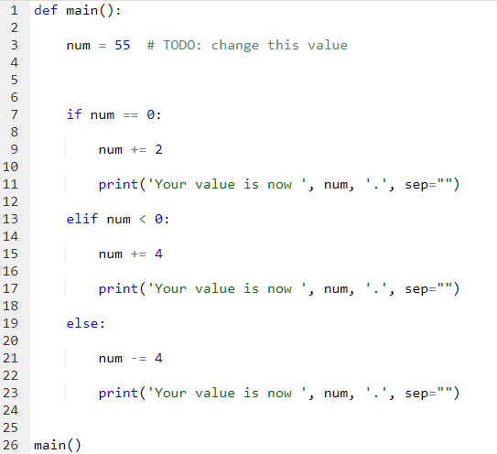  
     
   

Practice with Nested Loops. Enter the following code into [the Online Python 3 Tutor](http://www.pythontutor.com/visualize.html#code=&mode=undefined&cumulative=false&py=3):

line = 1

for i in range(1, 4):

for j in range(1, i+1):

print('Line ', line, ': (', i, ', ', j, ')', sep="")

line += 1

Try to predict what this loop will do. Answer Questions 9-12 in your writeup. Then use the tutor to step through this loop and check your work.  
  
The loop will iterate over the different values of ‘i' and ‘j’ and print accordingly.  
  
‘i’ iterate over 1,2 and 3 and ‘j’ will iterate over different values for every value of ‘i'.  
When ‘i’ is 1, j will iterate over 1. When ‘i’ is 3, ‘j’ will iterate over 1,2 and 3.

After every iteration, we print f“Line {line_number}: ({x}, {y})”. After that, we also increase the value of line by 1 to signify a new line.   
  
